**Git and GitHub**

## What is Git?

Git is a popular version control system.

It was created by Linus Torvalds in 2005, and has been maintained by Junio Hamano since then.

It is used for:

* Tracking code changes
* Tracking who made changes
* Coding collaboration

Working with Git

* Initialize Git on a folder, making it a **Repository**
* Git now creates a hidden folder to keep track of changes in that folder
* When a file is changed, added or deleted, it is considered **modified**
* You select the modified files you want to **Stage**
* The **Staged** files are **Committed**, which prompts Git to store a **permanent** snapshot of the files
* Git allows you to see the full history of every commit.
* You can revert back to any previous commit.
* Git does not store a separate copy of every file in every commit, but keeps track of changes made in each commit!

Git Workflow Commands Overview

* [Working Directory](https://www.w3schools.com/git/git_workflow.asp?remote=github#working-directory) - Where you make changes
* [git add](https://www.w3schools.com/git/git_workflow.asp?remote=github#git-add) - Stage changes
* [git commit](https://www.w3schools.com/git/git_workflow.asp?remote=github#git-commit) - Save changes to your repository
* [git push](https://www.w3schools.com/git/git_workflow.asp?remote=github#git-push) - Share changes with others
* [git status](https://www.w3schools.com/git/git_workflow.asp?remote=github#git-status) - Check what's going on
* [Undo/Amend](https://www.w3schools.com/git/git_workflow.asp?remote=github#undo) - Fix mistakes (git restore, git reset, git commit --amend)

**GitHub**

**GitHub** is a **web-based platform** used by developers to **store, manage, and share code**. It uses **Git**, a version control system, to track changes in code and allow collaboration among multiple people.

If we make changes on our system then we can reflect the changes on github.

• **Creating a GitHub repository**

• **Pushing code to GitHub using Git**

• **GitHub Pages (hosting websites)**

• **Collaborating on GitHub (pull requests, branches, issues)**

• **Setting up Git and GitHub for the first time**

• **GitHub Classroom or event repositories**

• **Creating a README.md or LICENSE file**

Key Git and GitHub Concepts

* **Repository:** A folder where Git tracks your project and its history.
* **Clone:** Make a copy of a remote repository on your computer.
* **Stage:** Tell Git which changes you want to save next.
* **Commit:** Save a snapshot of your staged changes.
* **Branch:** Work on different versions or features at the same time.
* **Merge:** Combine changes from different branches.
* **Pull:** Get the latest changes from a remote repository.
* **Push:** Send your changes to a remote repository.

## Complete Guide: Git & GitHub (From Beginning to End)

* 1. **Create a GitHub**

## Go to <https://github.com>

## Install Git

* First, install Git on your system.
* Download: <https://git-scm.com/downloads>

**# Check if Git is installed**

**Command:-**

|  |
| --- |
| **git –version** |

## Set Up Git (First-Time Only)

## Open git Bash --🡪

|  |
| --- |
| * git config --global user.name "Your Name" * git config --global user.email [you@example.com](mailto:you@example.com) * git config –list |

This sets your identity for all your commits.

**Two-Way Workflow of Git & GitHub**

### ****1. Local System → GitHub****

### ****2. GitHub → Local System****

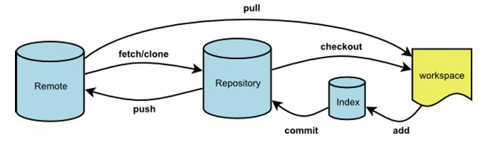

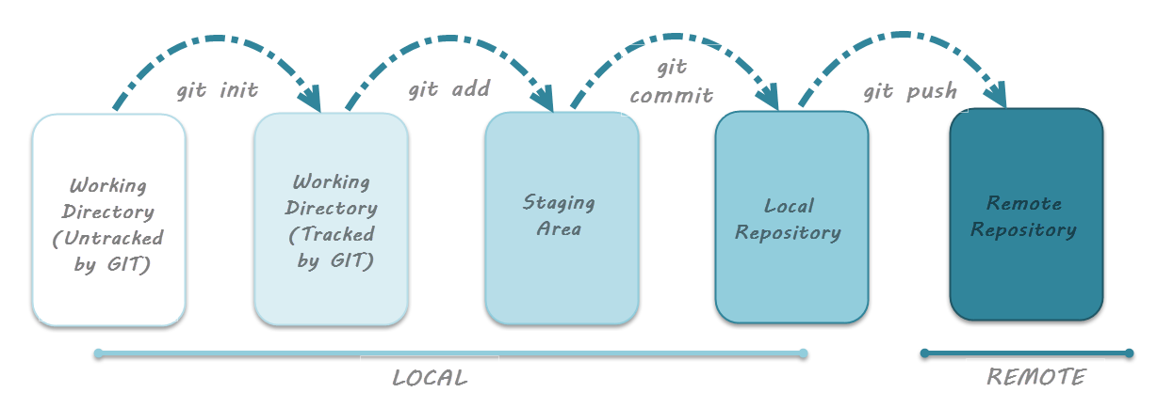

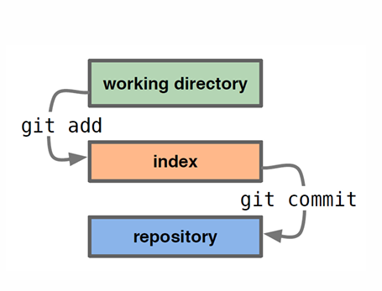

### ****1. Local System → GitHub****

|  |
| --- |
| All basic commands for Local to remote  git init  git remote add origin <link>  git remote –v  git branch  git branch –m main  git push origin main |

You **create a project on your local system** and then **push it to GitHub**.

|  |
| --- |
| **Step 1: Create local project folder and Go to your project folder(VS CODE)**  **Mkdir my-project**  **cd my-project**  **Note :-** Now we need to initialize this local folder as a Git repository.  **Step 2 : Check this repo is git repo or local folder**  **ls –a(mac)**  **ls –Force(window)**  **Step 3: Initialize Git(go to folder)**  **git init**  **ls –a**  **Step 4 : Check status**  **git status**  **Step 5: Add your files**  **#Create new files**  **git status**  **git add .**  **Step 6 : Check status**  **git status**  **Step 7: Commit your changes**  **git commit -m "Initial commit"**  **Step 8: Check status**  **git status**  **Step 9: Create a new repo on GitHub (no README)<go to git hub>**  **Step 10: Connect local to GitHub(vs code terminal)**  **git remote add origin <repo link>**  **To verify remote**  **git remote –v**  **Check branch**  **git branch**  **To rename branch( master 🡨🡪 main)**  **git branch -m main**  **Note :- First Push(Initial push only)**  **git push –u origin main**  **Note :- If Github content is updated then we need to perform pull/fetch before performing push**  **Step 11 : First, pull the remote changes**  **git pull origin main --allow-unrelated-histories**  **or**  **git pull origin main**  **or**  **git fetch origin main**  **Step 12: Create one file.**  Your_name.txt  **Note :- Now in VS code perform all these commands : status check, add, commit, status check, push**  **Step 13: Push code to GitHub**  **git push -u origin main**  **Note :- Now create README.md file in VS code and status check, add, commit, status check, push**  **Note :- Before performing any push we always need to pull all the update from github repo after that we are able to push** |

### ****Task 1(Marks 2) :-****

### Create a folder on your local system named **"LOCAL_REMOTE"**. Then, follow the procedure to push from local to remote. Inside the remote repository path “ ****CodeVerse_2025/Your_team_id_your_team_name / GIT _GITHUB/TASK_1/YOURFILE** ”**, create a file with your name, for example **your_name.txt**. After that, follow the same process to add, commit, and push this file to the remote repository.

### ****2. GitHub → Local System****

You **clone an existing GitHub repository** to your **local system** to work on it.

|  |
| --- |
| **Step 1: Copy the GitHub repo link**  • Copy the repository link from GitHub (HTTPS or SSH).  • Open terminal/command prompt where you want the folder.  **Check git version**  git –version  **Step 2: Clone the repo**  git clone repo link  **Step 3: Move into the project folder**  cd repo-name  ls  ls -a  **Step 4: Make changes, commit, and push as usual**  **Note :- Git status >add>commit >push**  git status  git add .  **Note :- (add . or add file name)**  git commit -m "Your message"  git push origin main |

**TASK 2 ( Marks 2)-**

**Create an empty folder on your local system. Then, using VS Code, clone the "CodeVerse_2025" repository from GitHub into that local folder. After cloning, go to the subdirectory your_team_id_team_name/GIT_GITHUB/TASK_2 and create a file named TEAM-ID_YOUR_NAME. Once the file is created, add, commit, and push the changes so that they are reflected in the GitHub repository. This entire process should be done following the Remote to Local procedure.**

**Summary :**

**GIT Repo Status :-**

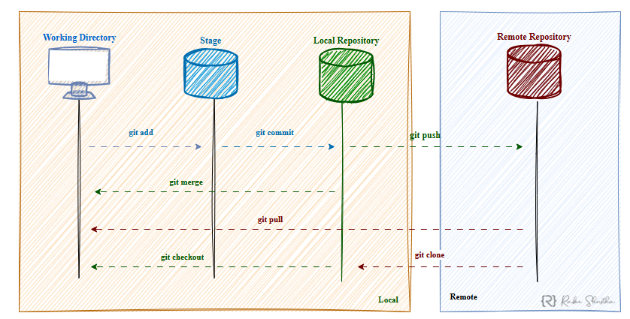

|  |  |  |  |
| --- | --- | --- | --- |
| **1.** | **Untracked** | A file is in the untracked state when it exists in your project directory but is not yet being tracked by Git for version control. | File created but not added |
| **2.** | **Modified** | Changed | Change 🡪Modify |
| **3.** | **Staged** | File is ready to be committed | Changed 🡪add 🡪modify |
| **4.** | **Unmodified** | Unchanged | change 🡪modifeid 🡪add 🡪commit 🡪unchange |

**GIT BRANCH**

* Git branch is used to **manage branches** in a Git repository.
* In Git, a branch is like a separate workspace where you can make changes and try new ideas without affecting the main project. Think of it as a "parallel universe" for your code.

**Common Reasons to Create a Branch**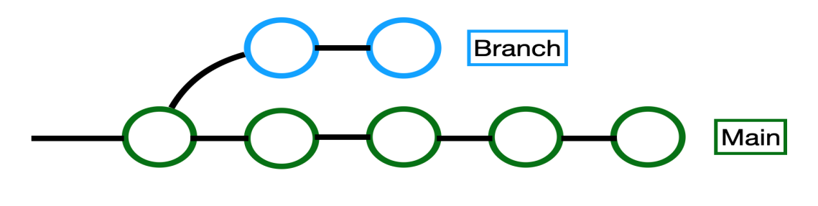

* Developing a new feature
* Fixing a bug
* Experimenting with ideas

|  |  |
| --- | --- |
| **Use** | **Command** |
| List all branches | git branch |
| Create a new branch | git branch new-branch-name |
| Switch to another branch | git checkout branch-name  or  git switch branch-name |
| Create and switch in one command | git checkout -b new-branch-name  or  git switch -c new-branch-name |
| Delete a branch | git branch -d branch-name |
| Force delete (if not merged) | git branch -D branch-name |
| To rename branch | Git branch –m main |

Example:-

* git branch
* git branch features
* git branch feature 1
* git checkout features
* git branch
* git branch –d feature1
* git branch
* git checkout –b nidhi
* git branch
* git branch –d nidhi
* git branch
* git checkout main
* git branch –d nidhi
* git branch
* change content of any file
* git status
* git add .
* git commit –m “message”
* git checkout features
* git checkout main
* git push origin features

# Git Branch Merge

* Merging in Git means combining the changes from one branch into another.
* This is how you bring your work together after working separately on different features or bug fixes.

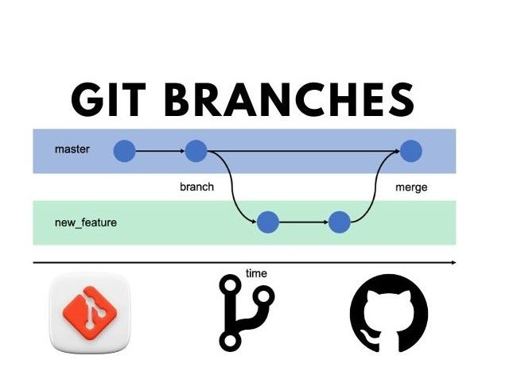

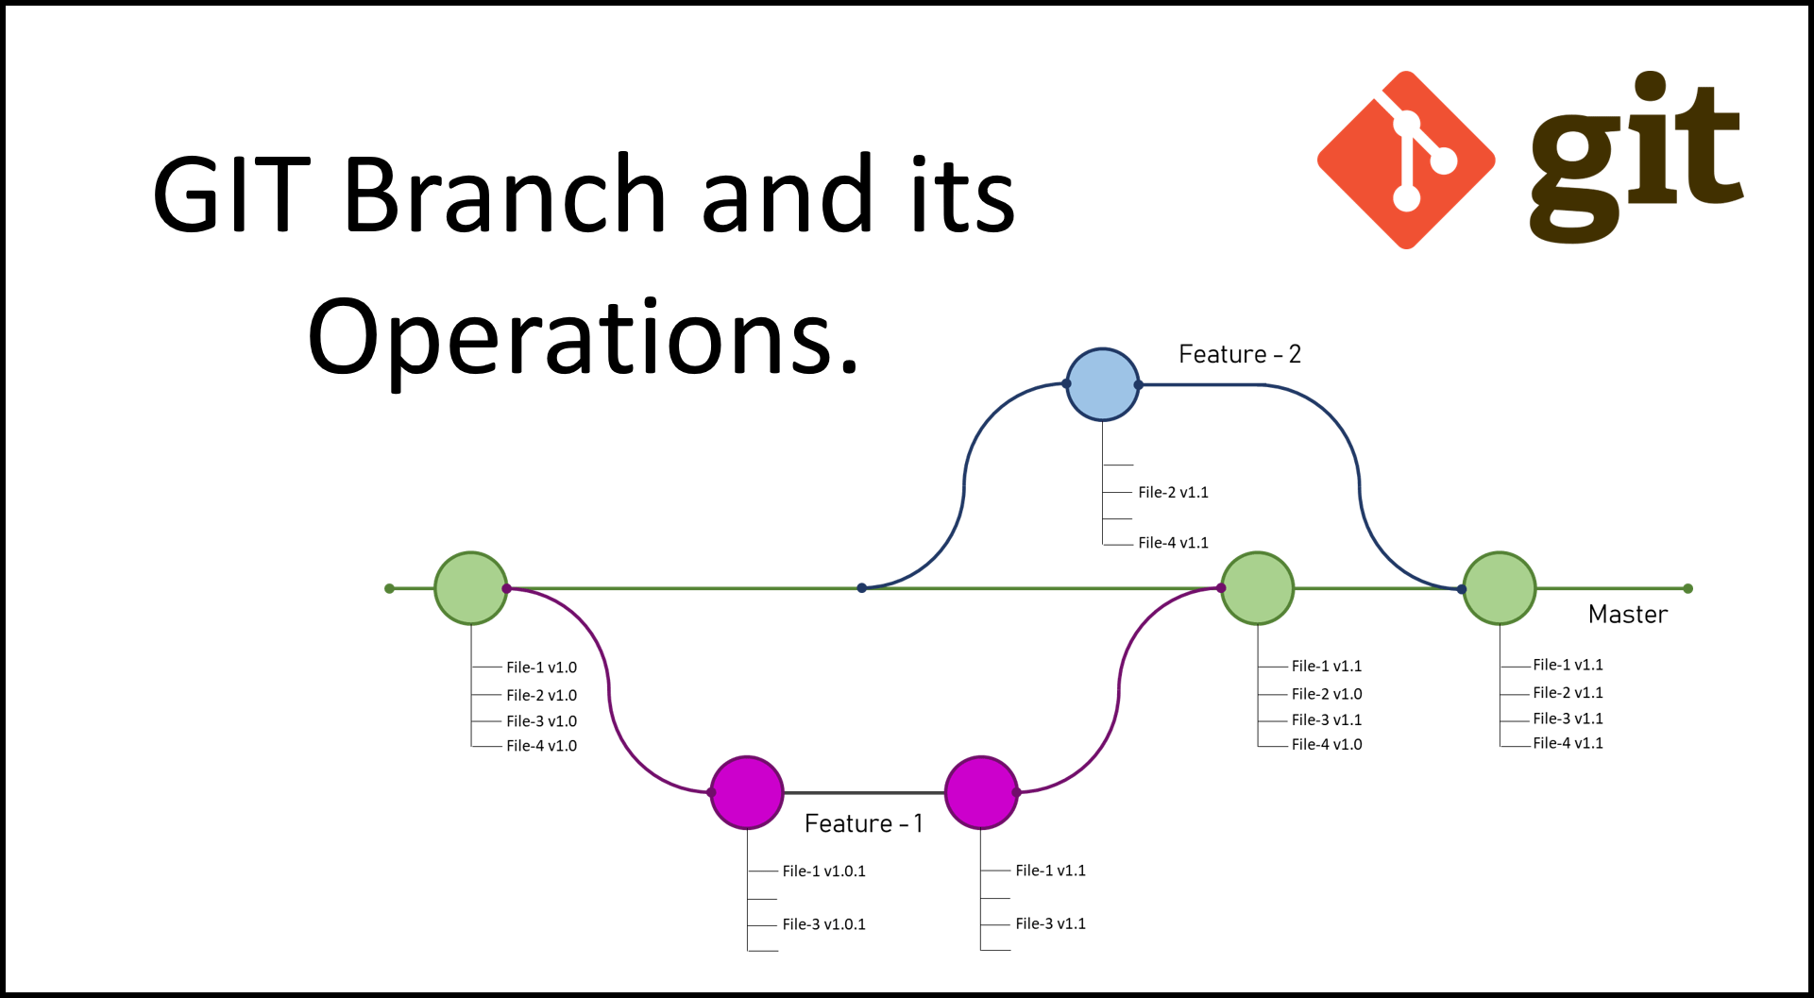

## Common git merge Options

* [git merge](https://www.w3schools.com/git/git_branch_merge.asp?remote=github#merge) - Merge a branch into your current branch
* [git merge --no-ff](https://www.w3schools.com/git/git_branch_merge.asp?remote=github#no-ff) - Always create a merge commit
* [git merge --squash](https://www.w3schools.com/git/git_branch_merge.asp?remote=github#squash) - Combine changes into a single commit
* [git merge --abort](https://www.w3schools.com/git/git_branch_merge.asp?remote=github#abort) - Abort a merge in progress

**Two Ways of Merging in Git and GitHub:-**

* 1. Merging Using a **Pull Request** (on GitHub)
  2. Resolving Merge Conflicts

**1. Merging Using a Pull Request (on GitHub)**

A **Pull Request (PR)** is the **recommended way** to merge code when working in teams. Instead of running git merge in your terminal, you request GitHub to do the merging after review.

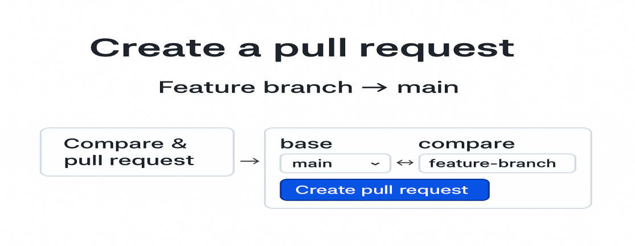

**Steps to Merge with a Pull Request**

**1. Push Your Feature Branch to GitHub**

|  |
| --- |
| git checkout -b feature-branch  # make changes  git add .  git commit -m "Add feature"  git push origin feature-branch |

**2. Open Pull Request on GitHub**

|  |
| --- |
| 1. Go to your GitHub repository. 2. GitHub will show: **"Compare & pull request"** → Click it. 3. Choose:    * **Base branch** (e.g., main)    * **Compare branch** (your feature-branch) 4. Add title, description, and submit the PR. |

### 3. Review & Merge

* Team members can review your PR.
* After approval (Check pull conflict 🡪 No conflict 🡪 Merge pull request 🡪 Pull request successfully merged and closed), click **"Merge pull request"**.
* Confirm the merge and optionally **delete the branch**.

**TASK 3 ( Marks 2)- create 4 branchs, delete 3 branchs, merge one branch with main branch(without conflict)**

* 1. **Resolving Merge Conflicts**

A **merge conflict** happens when Git can’t automatically merge changes from two branches (usually because the **same line(s)** in a file were edited differently in each branch).

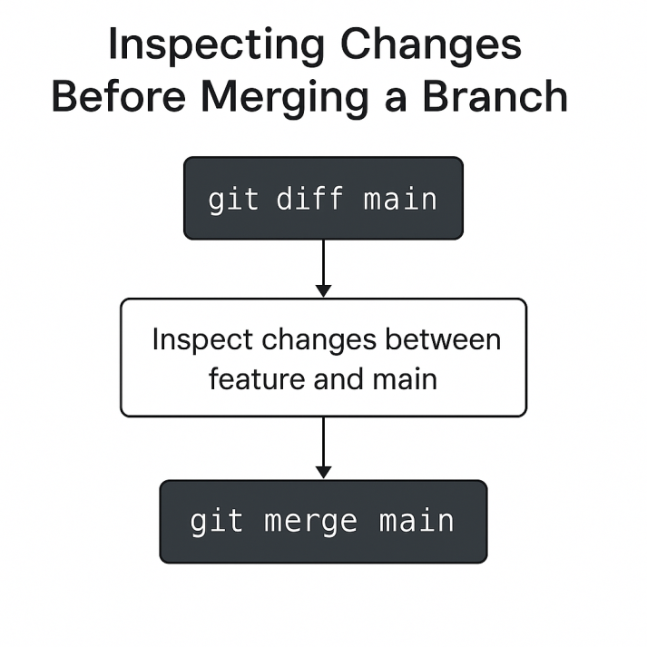

**Features 🡪 add dropdown 🡪add 🡪 commit**

**Main 🡪add button 🡪add 🡪commit**

**1. git diff main**

git diff main #(feature 1)

Shows the difference between your current branch and the main branch but **does NOT change anything.**

**Purpose:**

* Review changes before merging.
* See what's **different** between branches.

**Example:**

git checkout feature-branch

git diff main

**Output:**

* You’ll see code changes made in feature-branch that differ from main.

### 2. git merge main

**Merges the main branch into your current branch.**

**Purpose:**

* Bring changes from main into your working branch.
* Useful if main has been updated (to avoid conflicts later).

**Example:**

git checkout feature-branch

git merge main

If there are conflicts: You must resolve them.

**ERROR REFLECTS 🡪Choose any one option 🡪 add 🡪 commit 🡪git diff 🡪 go to main 🡪 git merge feature 1 🡪 git push**

**Typical Flow Combining Both:**

git checkout feature-branch

git fetch origin

git diff main # Check differences before merging

git merge main # Merge main into feature branch

Then resolve any conflicts → git add . → git commit

**TASK 4 ( Marks 2)- Resolve merge conflict and merge two branch**

**Undoing Changes in Git**

Git gives you multiple ways to undo changes depending on the **stage of the change**:

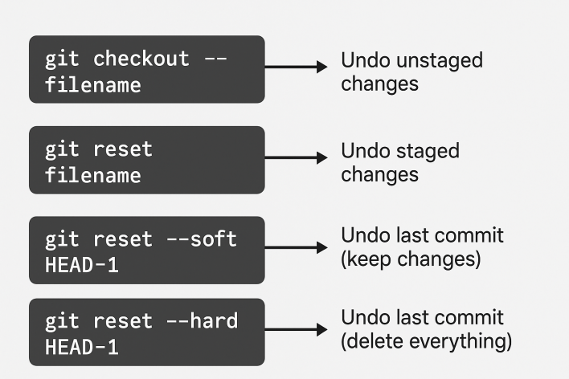

1. Undo Unstaged Changes

2. Undo Staged Changes

3. Undo Last Commit (Keep Changes)

4. Undo Last Commit (Unstage Changes)

5. Undo Last Commit (Delete Everything)

6. Undo a File from a Specific Commit

**1. Undo Unstaged Changes**

Changes made but not added to staging

git checkout – filename

Restores the file to the last committed version (deletes local edits).

**2. Undo Staged Changes**

Changes added with git add, but not yet committed

git reset filename or git reset HEAD ~1 # one step back

4

3

2

1

C1 C2 C3 C4 (HEAD)

git log # check log

Unstages the file, but keeps the local edits.

**3. Undo Last Commit (Keep Changes)**

git reset --soft HEAD~1

Removes the last commit but keeps files staged.

**4. Undo Last Commit (Unstage Changes)**

git reset --mixed HEAD~1

Removes last commit and unstages files (keeps your code).

**5. Undo Last Commit (Delete Everything)**

git reset --hard HEAD~1

Deletes the commit and code changes permanently.

**6. Undo a File from a Specific Commit (FOR MANY COMMITS OR COMMITTED** CHANGES)

git checkout <commit_hash> -- filename

OR

git log 🡪Hash 🡪copy

git reset Hash

git status

git log 🡪 History

git reset --hard Hash #both git / vs code remove changes

|  |
| --- |
| git reset < commit Hash >  git reset --hard < commit Hash > |

**Fork**

A **fork** is a **copy of a repository** that lives on your GitHub account.

It lets you:

* Make changes freely without affecting the original project
* Submit pull requests to suggest changes to the original
* Experiment or build independently

How Forking Works

• You find a repository on GitHub

• Click the **Fork** button (top-right corner)

• GitHub creates a **copy of the repo under your account**

• You clone your fork to your local system:

**git clone repo link**

• Make changes in your fork

• Push changes and submit a **Pull Request** to the original repo

Open other’s repo 🡪 go to fork 🡪 if you want to contribute to that project 🡪 as in same master or new branch

Click add file 🡪 new file created 🡪 save file 🡪 commit

COMMIT

Create new branch for this commit 🡪 Start PULL Request

Commit directly to the master branch

**Pull Request 🡪New Pull Request 🡪 Click on your change file 🡪 Create pull request**

**Fork vs Clone**

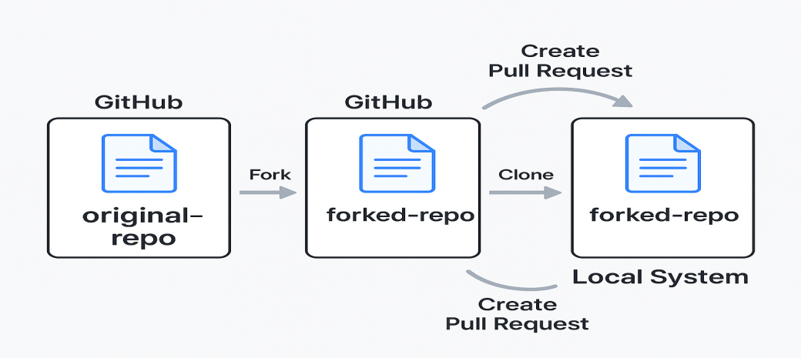

|  |  |  |
| --- | --- | --- |
| **Action** | **Fork** | **Clone** |
| Purpose | Copy repo to **your GitHub account** | Copy repo to your **local system** |
| Use Case | Open-source collaboration, submitting PRs | Local development |
| Scope | Happens on GitHub (remote) | Happens on your computer (local) |

**TASK 5 ( Marks )- Fork one repository.**

**Git & GitHub Collaboration :-**

GitHub Invitation :- A **GitHub invitation** allows someone to **collaborate** on a repository or join an organization.

## 1. ****Invite to Collaborate on a Repository****

Steps:-

1. Go to your GitHub repo
2. Click **"Settings"** → **"Collaborators"**
3. Click **"Add people"**
4. Enter their GitHub username or email
5. Click **"Invite"**

### 

They will receive an **email** and a **GitHub notification** to accept.

### After Accepting:

* The invited user gets **access to the repo**
* They can **clone, push, open pull requests**, etc., based on permission

**2. Common Collaboration Workflow**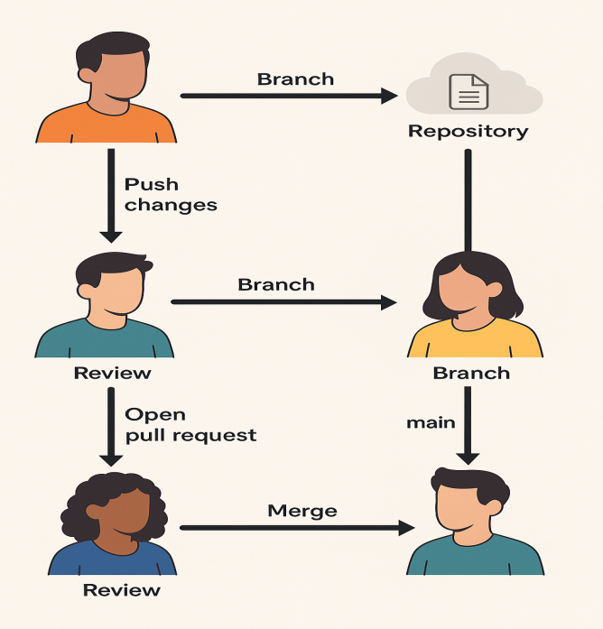

**1. Clone the Repository**

**2. Create a New Branch**

**3. Make Changes, Then Stage & Commit**

**4. Push to GitHub**

**5. Open a Pull Request (on GitHub)**

**6. Review & Merge**

Git Workflow Commands Overview

* [Working Directory](https://www.w3schools.com/git/git_workflow.asp?remote=github#working-directory) - Where you make changes
* [git add](https://www.w3schools.com/git/git_workflow.asp?remote=github#git-add) - Stage changes
* [git commit](https://www.w3schools.com/git/git_workflow.asp?remote=github#git-commit) - Save changes to your repository
* [git push](https://www.w3schools.com/git/git_workflow.asp?remote=github#git-push) - Share changes with others
* [git status](https://www.w3schools.com/git/git_workflow.asp?remote=github#git-status) - Check what's going on
* [Undo/Amend](https://www.w3schools.com/git/git_workflow.asp?remote=github#undo) - Fix mistakes (git restore, git reset, git commit --amend)

